CV

Personal information:
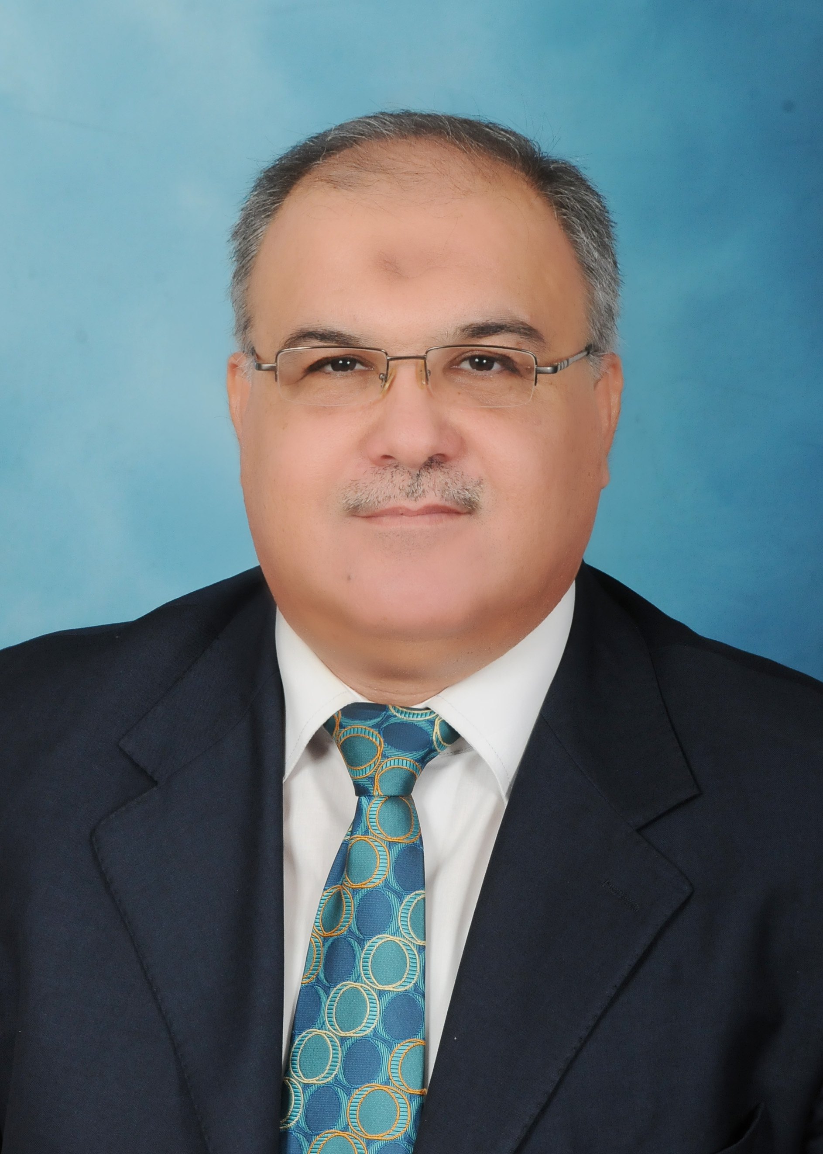

Name: Abdullah Ahmed Abdullah Alhaj
Nationality: Jordanian
Date & place of birth: 21-04-1964 Almafraq –Jordan
Marital status: married
Address: The University of Jordan/Aqaba
E-mail: aa.alhaj@ju.edu.jo
aaalhaj@yahoo.com
Mobile No: +962777738584
Telephone No: +96232090450-Ext. (35117)

Education:

- PhD in Computer Science (Networking & IT Security).
The University of Bradford –United Kingdom-2007
- B. Sc & M.Sc. in Computer Engineering-computer
architecture –USSR-1988.
- Tawjihi Certificate –Scientific stream HKJ- 1982

Working experience :

1) 1/9/2017 - Present, Dean of IT and Systems faculty &
General Registrar.
    - 11/09/2011- Up to date. The University of Jordan/Aqaba, Faculty of IT and Systems – Department of BIT.
    - Dean of IT and Systems faculty until 31/08/2013.
    - Head of CIS & BIT departments until 31/08/2012.
    - Head of commission of inquiry with employees until 31/08/2013.

  - Subject taught for M.Sc. Students:

    - Graphic design
    - WEB design
    - IT in education
    - Supervision of a group of graduation projects.

  - Subject taught for B.Sc. Students:

    - IT security.
    - Computer networks.
    - Computer architecture.
    - Internet and web design.
    - Digital logic.
    - Operating systems
    - Decision support systems
    - Computer skills for humanities
    - Supervision of a group of graduation projects.

  - 17/2/2008 – 31/08/2011 Alisra University –Amman
During this period:

    - 2008/2009 Member of The University Committee.
    - 2009/2010 Member of IT faculty committee.
    - 2009-2011 Head of commission of inquiry with students and Head of social committee.

  - In this period I taught the following subjects:

    - IT security.
    - Computer networks.
    - Computer architecture.
    - Internet and web design
    - Digital logic
    - Introduction to computer (1).
    - Introduction to computer (2).
    - Computer applications for scientific colleges.
    - Computer in education for the humanitarian faculties.
    - Advanced computer applications.
    - I guided a lot of graduate projects.

  - 9/1999- 2/2007 - Ministry of Higher Education \ Sultanate of
Oman \ Rustag College of education. I worked as a full-time
lecturer in the math. and computer science department ,
subjects taught for different specialties and computer
science specialty are:

    - Introduction to computer 1.
    - Introduction to computer 2.
    - Computer applications.
    - Computer in education.
    - Advanced computer applications.
    - Operating systems.
    - Digital electronics and circuit design.
    - Internet and web design.
    - Computer architecture.
    - Computer networks.
    - Information security.
    - I guided 3 graduate projects in MP-based system, computer networking and database.

4) 1997-1999 Al-Omani Institute for Vocational Training\Muscat-
I worked as instructor to teach:

    - Different software applications and internet courses.
    - I was responsible for the maintenance of all computer hardware in the institute and its branches and worked as instructor to teach courses in computer hardware maintenance.

  - 1995-1996 Al-tahaddi University\Libya- Lecture in
Computer Engineering Faculty.
  - Subjects taught:

    - Digital electronics.
    - Microprocessor principles and applications.
    - Computer circuits and digital design.
    - Introduction to computer (Assembly language).
    - I guided many graduate projects.

6) 1991-1995 Ministry of education /Libya, I worked as a lecturer,

  - Subject taught both theoretical and practical:

    - Different types of operating systems.
    - Programming languages.
    - Different Software applications.
    - Different hardware subjects

7) 1988-1990- Royal Jordanian Air forces support, maintenance and training Engineer.

Published Papers:
- Nabeel Zanoon, Abdullah Al-Haj and Sufian M Khwaldeh, Cloud Computing and Big Data is there a Relation between the Two: A Study. International Journal of Applied Engineering Research ISSN 0973-4562 Volume 12, Number 17 (2017) pp. 6970-6982.
- Shadi AlJawarneh ,Reem Jaradat, Abdel Salam Maatuk,and Abdullah Alhaj, Gene Profile Classification: Aproposed Solution for Predicting Possible Disease and Initial Results , IEEE –Computer Society- Proceedings of ICEMIS2016, Accepted- to be published on October, 2016.
- Abdullah Alhaj, Shadi AlJawarneh , A Mechanism for Securing Hybrid Cloud Outsourced: Securing Hybrid Cloud, International Journal of Cloud Application and Computing, IGI, E-book Chp.6,2015
- Abdullah Alhaj, How Literacy Rate, GDP (PPP) and Gender Constrain and Effect Social Contagion in Social Networking (Twitter). Recent Patents on Computer Science. Bentham Science. Vol.8, Issue:2. No.5, pp.85-89.Aug., 2015.
- Abdullah Alhaj, Performance Evaluation of Secure Data Transmission Mechanism (SDTM) for cloud outsourced data and Transmission Layer Security (TLS). International Journal of Cloud Applications and Computing.IGI. 4(1),45-49,January-March. 2014.
- Shadi Almasaedeh, Shadi Jawarneh,Ashraf Odeh and Abdullah Alhaj, Secure Communication: A proposed Public Key Watermark System. International Journal of Information Security and Privacy 7(4),1-10, October-December 2013.
- Abdullah Alhaj, Shadi Aljawarneh, Shadi Masadeh and Evon Abu-Taieh, A Secure Data Transmission Mechanism for Cloud Outsourced Data. International Journal of Cloud Applications and Computing, 3(1), 34-43, January-March 2013
- Shadi Jawarneh, Abdullah Alhaj, Testing and evaluation of a secure integrating measurement system (SIMS) for remote system. IAJIT Vol. 9. No 3 May 2012
- A.Alhaj, J.Mellor, I.Awan, Performance Analysis of Secure Call Admission Control for Multiclass Internet Services, 23rd IEEE-AINA'09 (UK-Bradford), IEEE -CS proceeding. May, 2009.
- A.Alhaj, J.Mellor and I.Awan, “Performance Analysis of Secure Call Admission Control in Heterogeneous Networks. IEEE-NGMAST’07 (UK), IEEE -CS proceeding, 2007.
- A.Alhaj, J.Mellor and I.Awan, “Performance evaluation of Secure Call Admission Control in Heterogeneous Networks and Secure Socket Layer. IEEE-4GCC (Bahrain), in IEEE-CS proceeding, 2007.
- Alhaj, J.Mellor and I.Awan, Technical Comparison between Secure Call Admission Control in Heterogeneous Networks and SSL, in the proceedings of the 2nd Conference ‘’Advances in Computer Security and Forensics (UK), July. 2007. pp. 10-12.
- A.Alhaj, J.Mellor and I.Awan, “Secure Call Admission Control in Heterogeneous Networks,” in Proceedings of the eighth informatics workshop (D. Rigas, ed.), (UK), University of Bradford, June 2007. pp. 43-46.
- Alhaj, J.Mellor and I.Awan, IPsec Based Multifence Secure Call Admission Control in Heterogeneous Networks, PG Net (UK), June. 2007. pp. 401-406.
- Alhaj, J.Mellor, I.Awan and Raied Salman, “The Insecurity of IEEE 802.11 WEP,”in Proceedings of the seventh informatics workshop (D. Rigas, ed.), (UK), University of Bradford, March 2006.
Languages:
- Arabic
- English
- Russian

